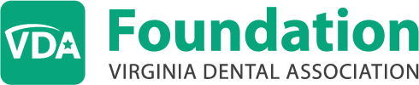

Stock Transfer Instructions

VDAF’s Brokerage Firm | Charles Schwab & Company  PO Box 628291  Orlando, FL 32862-8291
Deliver to: | Bank of New York Mellon
 | ABA# 021000018
 | BK of NYC/CSCHWAB
Credit to Account: | VDAF Account #; FBO Virginia Dental Association Foundation
Account #: | Please contact Tara Quinn, VDAF Executive Director, at 804-523-2181 to receive the Foundation’s account information.
Questions: | Please contact Tara Quinn, VDAF Executive Director, at 804-523-2181 to receive the Foundation’s account information.

